
Content

Repurposing Calendar



Content Remix | Repurposing Content with the help of ChatGPT




This worksheet will help you maximize the value of your existing content by turning one great idea into multiple posts, formats, and platforms — without burnout or repetition. Repurposing is about working smarter, not harder. Instead of constantly creating from scratch, you’re giving your best content new life in different formats. It keeps your message consistent and saves time.

How to Use This Worksheet

Choose one core piece of content each week (a story, video, or blog).
Use the calendar on the following pages to brainstorm multiple ways to share it.
Post each variation across different platforms and formats.
Track your engagement to see which repurposed formats perform best.

Quick Tip:
Social media content updates by the minute, so it’s likely most people missed your post the first time. Don’t be afraid to reuse your strongest ideas. I give my content about a month in between repurposing (I post 5x/week). If you post less frequently, your in-between waiting time should be longer.

Content Remix
Start with one original piece of content and brainstorm how to adapt it across platforms and styles.REMINDER: You do NOT need to be on every platform! That can get overwhelming. It’s better to be consistent on one or two of your best platforms, rather than inconsistent on all of them.
Original Idea / Story

Customer Testimonial
Platform

Instagram

Facebook

LinkedIn
Repurposed Format

Carousel

Long-Form Post

Article
New Angle / Headline

Shine a spotlight on your
customer’s feedback to ultimately showcase your company’s involvement in their success
(without outright bragging!) “How One Small Change Doubled This
Customer’s Capacity”
How One Company Easily Doubled Their Capacity
If you’re in
manufacturing, do this to double your capacity easily
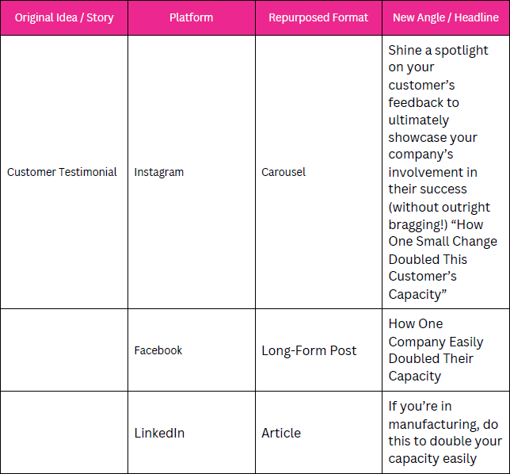

Original Idea / Story
Platform

Email Newsletter

TikTok / Reels
Repurposed Format

Short Story

Video Clip
New Angle / Headline
Why this
customer’s
success matters to you
The Moment Everything
Changed for This Customer

Content Remix

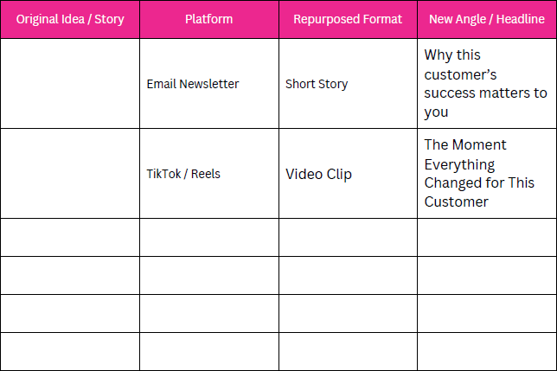

Planning Tip:
Each repurposed piece should focus on one key takeaway — not every detail. Simplify and personalize.

Repurposing Content with the help of

ChatGPT

Use these prompts when you’re not sure how to repurpose something.

Prompt Type |  | Example / Use Case

Turn a quote into a post. |  | “Pull one line from a podcast or video and make it your caption.”

Turn a blog into a Reel. |  | “Summarize your main point in under 30 seconds — add a visual example.”

Turn an email into a carousel. |  | “Break your newsletter tips into 3–5 slides with visuals.”

Turn a testimonial into a story. |  | “Share what the customer said and how you helped them achieve it.”

Repurposing Content with the help of

ChatGPT

Use these prompts when you’re not sure how to repurpose something.

Prompt Type |  | Example / Use Case

Turn FAQs into posts. |  | “Each question can become its own mini educational post or video.”

Revisit an old post. |  | “Update the caption with what you’ve learned since then.”

Final Tip:
Repurposing keeps your message alive. Every time you share a story differently, you give it another chance to connect.

